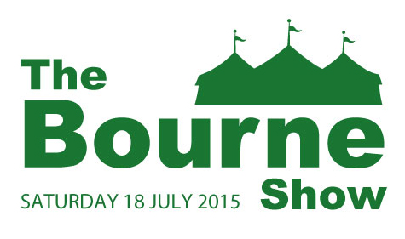

OWNERS OF VINTAGE AND CLASSIC VEHICLES ARE
INVITED TO ENTER THEIR VEHICLES

THREE CHALLENGE CUPS – FREE TEA
CARS TO ARRIVE AT 12.30

Follow the signs to the car paddock entrance at the rear of
The Bourne Green, to be on the green in time for your picnic, or maybe have some lunch at one of the Show’s food stalls

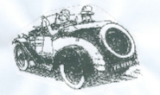

The Bean Car Club are kindly organising a Pre Show Run

Those who would like to participate should meet at:
THE FOX
21 Frensham Road, Lower Bourne, Farnham, GU10 3PH
(on the A287) At 10.30am for Coffee & Start

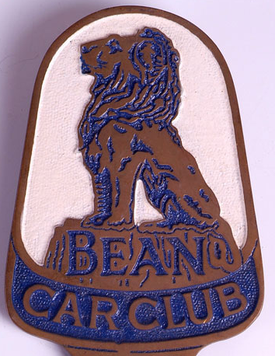
An entry fee of £2 will be charged to cover administration: Participants will be issued with a route map and instructions.

The Run culminates on The Bourne Green around 12.30pm

NB: Sorry due to limited space on the village green this event is not suitable for large post-war American classics

www.thebourneshow.com

